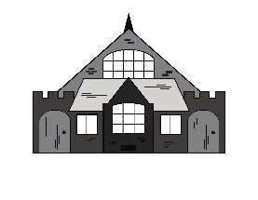
PAULTON VILLAGE HALL & MEETING ROOM
FIRE PROCEDURE

Any person discovering a fire should:

- Warn all other occupants of the building.
- Extinguish the fire if possible with the on-site appliances but only if
you have received training in the use of portable fire extinguishers.
- If unable to contain the fire, leave the building by the nearest fire exit and report to the Assembly Point

On being made aware of a fire all persons must:

- Leave the building immediately by the most direct safe route following the green Fire Exit signs.
- If necessary, give assistance to disabled/injured persons.
- Report to the designated Assembly Point
- Do not stop to collect personal belongings.
- Do not re-enter the building for any reason until advised it is safe to
do so.

Duties of Responsible Person:

- Call the Fire Brigade or delegate another person to do so, on 999.
- State the location and nature of the fire, and the area affected.
- Ensure that all persons are accounted for at the Assembly Point
- Meet and give assistance to the Emergency Services as appropriate.
- Notify all persons when it is safe to return to the building
.

ASSEMBLY POINT IS
THE TENNIS COURT

