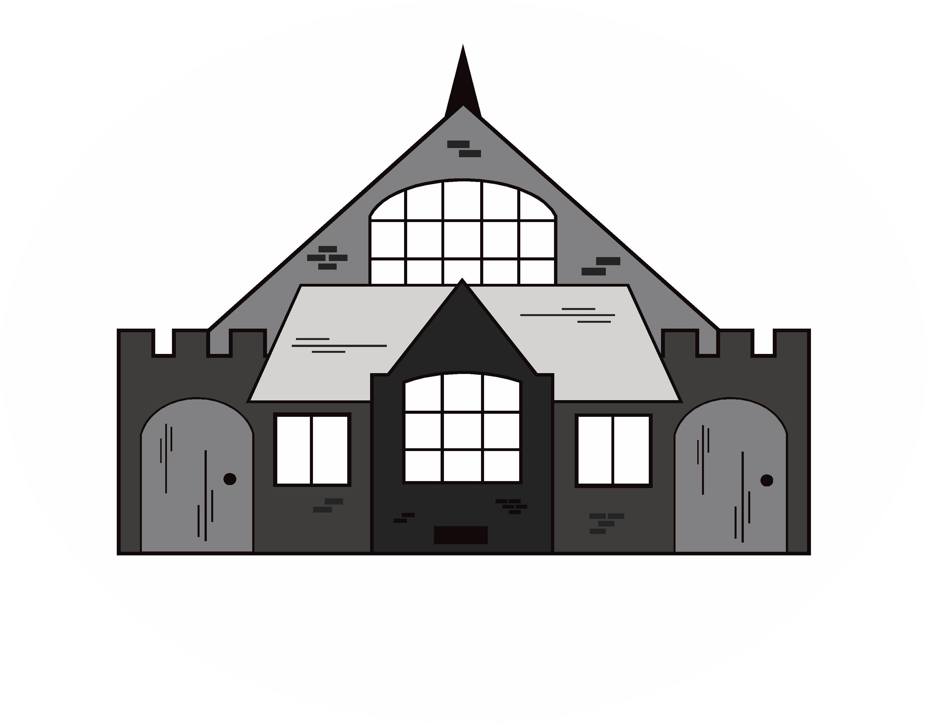
PAULTON VILLAGE HALL – CONDITIONS OF LETTINGS
Hall Administrator: 01761 413644 (office hours only 9am-4.30pm, Mon-Thurs)

These Terms and Conditions of Hire apply to all persons hiring the hall for functions. It is important you read and fully understand them before signing this and the booking form. If you have any questions, please contact the hall administrator.

BOOKING: Bookings for the hall must be made on the attached booking form. Dates are held for a maximum of 21 days before being released, unless full payment is made to secure. All hirers must be over the age of 18 at the time of booking.

PAYMENT: The cost of standard hire is calculated on an hourly basis and will have been explained at the time of booking. The hire fee must be paid at the time of booking. A deposit of £160 must also be paid at the time of booking. This is made up of £45 key deposit, £15 refuse deposit and £100 damage deposit. This is refundable as long as the hall is secured at the end of the period of hire, the keys are returned, no refuse is left on site and no damage is incurred. The premises must be left in a clean and tidy condition – all tables must be wiped down and tables and chairs returned to the store room. All electric lights must be turned off.

KEYS: Keys must be collected from the hall administrator at The Council Office, which is located to the rear of the hall, on or before the day of hiring. After securing the premises the key must be returned either the same day or following morning (by prior arrangement). For weekend hire the key must be collected by 12 noon on Friday and returned the following Monday morning after 11am.

USE OF PREMISES: The Hirer shall not use the premises for any purpose other than that described on the booking form and shall not sub-let the premises or allow the premises to be used for any unlawful purpose or way. Nor allow the consumption of alcohol thereon without prior notification at the time of booking.

SUPERVISION, DAMAGE & DEPOSIT: The Hirer shall, during the period of hiring, be responsible for the premises and grounds, all contents and the behaviour of all persons using the premises. The Hirer shall notify the hall administrator of any damage. If for any reason the deposit does not cover the cost, the Hirer agrees to meet the cost of making good any damage. This includes all damage caused during the period of hire (including accidental damage) to the premises or fixtures, fittings and any loss of contents.

DECORATIONS/ALTERATIONS: No alterations may be made to the premises nor may any fixtures be installed. Decorations to the hall are allowed provided they do not materially increase the fire risk, they will not cause damage, and they must be removed at the end of the hire period. The Hall Trustees have the authority to remove any decorations they deem unsafe.

HIRE PERIOD: We would like to remind you that your booked period of time includes all setting up and clearing away. If additional time is required this must be booked and paid for (subject to other events). This also applies to clearing up the following morning after a late-night party. All functions must finish and the hall cleared by midnight. Hirers are respectfully asked to leave the Hall and car park quietly.

ALCOHOL: The Hall is NOT licensed for the sale of intoxicating liquors, so the onus is on the hirer to apply for an occasional licence if required. You will need to contact B&NES (Bath and North East Somerset Council: 01225 394041) for details. The Hirer shall ensure that in order to avoid disturbing neighbours and avoid violent or criminal behaviour, care shall be taken to avoid excessive consumption of alcohol. Drunk and disorderly persons shall not be permitted on to the premises. Alcohol shall not be served to any person suspected of being drunk or to any person suspected of being under the age of 18. No illegal drugs may be brought onto the premises.

GAMING, BETTING & LOTTERIES: The Hirer shall ensure that nothing is done on or in relation to the premises in contravention of the law relating to gaming, betting and lotteries.

CAR PARK: The large car park is provided free (parking at owner’s risk) and Hirers should ensure that it is used properly, as the Policy may have to take action if cars are left on the road. The employment of a parking attendant for large numbers is helpful.

HEALTH AND HYGIENE: The Hirer shall, if preparing, serving or selling food, observe all relevant food health and hygiene regulations.

BOUNCY CASTLES/INFLATABLES: If hiring a bouncy castle or other inflatable, the Hirer should consider arranging their own public liability insurance as the Village Hall insurance does not cover the hiring and use of these in the Village Hall. THE HIRER MUST ENSURE THAT A REPRESENTATIVE FROM THE COMPANY STAYS WITH THE EQUIPMENT THROUGHOUT THE HIRE PERIOD. THE VILLAGE HALL CANNOT TAKE RESPONIBILITY FOR THE HIRE OF BOUNCY CASTLES OR OTHER INFLATABLES.

SMOKING: We would like to remind all Hirers that we operate a strict NO SMOKING policy throughout the premises.

ANIMALS: The Hirer shall ensure that no animals (including birds) except guide dogs are brought into the premises, other than for a special event agreed in writing prior to the booking by the Village Hall Trustees. No animals whatsoever are to enter the kitchen and food preparation area.

AMPLIFIED MUSIC: The Hirer shall, if using sound amplification equipment, comply with any other licensing condition for the premises and keep all noise to a minimum. If complaints are received from neighbours, the Police or other officials, we will retain the full deposit.

ELECTRICAL APPLIANCES & TEMPORARY EQUIPMENT: Any electrical equipment must meet required standards and used in a safe manner. Flexible cables should be positioned & protected so as not to constitute a tripping hazard.
Any temporary equipment brought into the hall by hirers must be certified as safe for purpose.

FIRE
- SMOKE MIST FOG MACHINES: Due to the sensitivity of the fire/smoke alarm these are NOT to be used.
- CANDLES: If candles are being lit – they are to be passed through the kitchen hatch and not walked out through the doors on either side of the kitchen as this sets the alarm off.

HALL FLOOR: The hirer should be aware that although the floor is not polished, due to its nature, it can be slippery. Care should be taken not to damage or scratch the floor.

CANCELLATION BY THE HIRER: If you cancel your booking, you will be liable for the cancellation charges set out below:
- Cancellations 21-29 business days prior to the booking date: 50% of the Hire Charge held will be refunded
- Cancellations 20 business days or less prior to the booking date: No refund is given

CANCELLATION BY THE VILLAGE HALL: The Village Hall reserves the right to cancel this hiring by written notice to the Hirer in the event of:
- The premises being required for use as a Polling Station for a Parliamentary or Local Government election or by-election.
- The Village Hall Trustees reasonably considering the function will lead to a breach of licensing conditions (if applicable), or other legal or statutory requirements or unlawful or unsuitable activities will take place at the premises as a result of this hiring.
- The premises becoming unfit for the use intended by the Hirer (e.g. power cut, etc).
- An emergency requiring use of the premises as a shelter for the victims of flooding, snowstorm, fire, explosion or those at risk of these or similar disasters.
- Government Guidance no longer permitting the use of the Hall for events or requirements cannot be met.

In any such case the Hirer shall be entitled to a refund of any deposit/charge already paid, but the Village Hall shall not be liable to the Hirer for any other fees or costs.

LICENCES: The hall is licensed and insured for a maximum of 200 people (100 seated). This number must not be exceeded. The Hirer shall ensure that entertainers hold a Performing Society Rights Licence.

IMPORTANT:
- The Trustees will not accept responsibility or liability in respect of damage, theft or loss of any property, goods, vehicles or other items whatsoever brought into or left in the Hall whether by the Hirer or on his behalf, before, during or following the period of letting.
- The Trustees reserve the right to refuse any application.
- The Trustees reserve the right of entry during the period of letting to any officer or representative of the Trustees and any Police Officer on duty at the time during the hire period.

HIRERS PRIVACY NOTICE

The information you provide (personal information such as name, address, email address, phone number) will be processed and stored so that it is possible to contact you and respond to your correspondence, provide information, send invoices and receipts relating to your hire agreement.
Your personal information will not be shared with any third party without your prior consent.

The Councils Right to Process Information

GDPR Article 6 (1) (a) (b) and (c) (Data Protection Act 2018)

Processing is with consent of the data subject
or
Processing is necessary for compliance with a legal obligation
or
Processing is necessary for the performance of a contract with the data subject or to take steps to enter into a contract

Information Security

Paulton Village Hall Charity cares to ensure the security of personal data. We make sure that your information is protected from unauthorised access, loss, manipulation, falsification, destruction or unauthorised disclosure. This is done through appropriate technical measures and relevant policies.

We will only keep your data for the purpose it was collected for and only for as long as is necessary. After which it will be deleted.

Your Rights

Access to Information

You have the right to request access to the information we have on you. You can do this by contacting our Data Information Officer: clerk@paultonparishcouncil.gov.uk

Information Correction

If you believe that the information we have about you is incorrect, you may contact us so that we can update it and keep your data accurate. Please contact: clerk@paultonparishcouncil.gov.uk

Information Deletion

If you wish Paulton Village Hall Charity to delete the information about you, please contact:
clerk@paultonparishcouncil.gov.uk

Right to Object

If you believe that your data is not being processed for the purpose it has been collected for, you may object: Please contact clerk@paultonparishcouncil.gov.uk

Rights Related to Automated Decision Making and Profiling

Paulton Village Hall Charity does not use automated decision making or profiling of personal data.

To Sum Up

In accordance with the law, we only collect a limited amount of information about you that is necessary for correspondence, information and service provision. We do not use profiling, we do not sell or pass your data to third parties. We do not use your data for purposes other than those specified. We make sure your data is stored securely. We delete all information deemed to be no longer necessary. We constantly review our Privacy Policies to keep it up to date in protecting your data.

Complaints

If you have a complaint regarding the way your personal data has been processed you may make a complaint to the Data Protection Officer, Local Council Pubic Advisory Service. ceo@lcpas.co.uk or 01284 766885.

By signing this form you agree to the Terms and Conditions and Privacy Notice set out above.

Signed for and on behalf of the Hirer: ......................................................................................................... (I am over 18 years of age)

Name in Capitals: ........................................................................................ Date: …………………………………………………………………

